**Orbit odissey – UI design** 이름: 후슬렝/20220142

* Main screen:

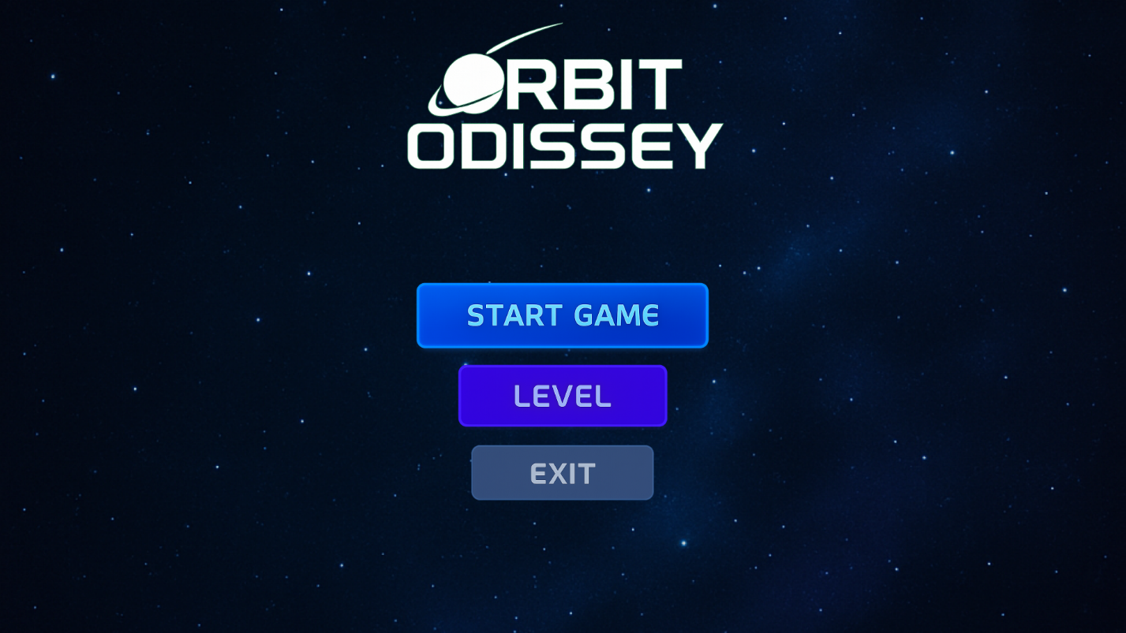

**Background :** dark and gloomy like space 1920x1080

**Logo**: Font Style: Sci-Fi / Futuristic (visually close to Orbitron, Exo, or Audiowide)

Text Size Estimate: ~96–120pt (for large title use)

Color: Text White: RGB(255, 255, 255)

Glow Accent (Blue-ish): RGB(0, 153, 255)

Planet/Ring Accent (Purple-ish): RGB(155, 93, 229)

Location: 691 , 691

**Start button:** Font Style: Sans-serif, bold (similar to Montserrat Bold or Orbitron)

Text Size Estimate: ~36–48pt

Text Color: RGB(255, 255, 255)

Gradient: Start: RGB(0, 191, 255) (electric blue)

End: RGB(100, 216, 255)

Glow Outline: RGB(0, 153, 255)

Location: 571, 571

**Level button:** Font Style: Sans-serif, clean (matches others)

Text Size Estimate: ~32–40pt

Text Color: RGB(0, 140, 255)

Gradient: Start: RGB(150, 110, 255)

End: RGB(90, 60, 180)

Glow: RGB(0, 180, 255)

Location: 468, 468

**Exit button:** Font Style: Same as above

Text Size Estimate: ~30–42pt

Text Color: RGB(255, 255, 255)

Gradient: Start: RGB(60, 70, 90)

End: RGB(120, 130, 150)

Glow: RGB(100, 149, 237) (cool steel blue)

Location: 427, 427

**You win screen:**

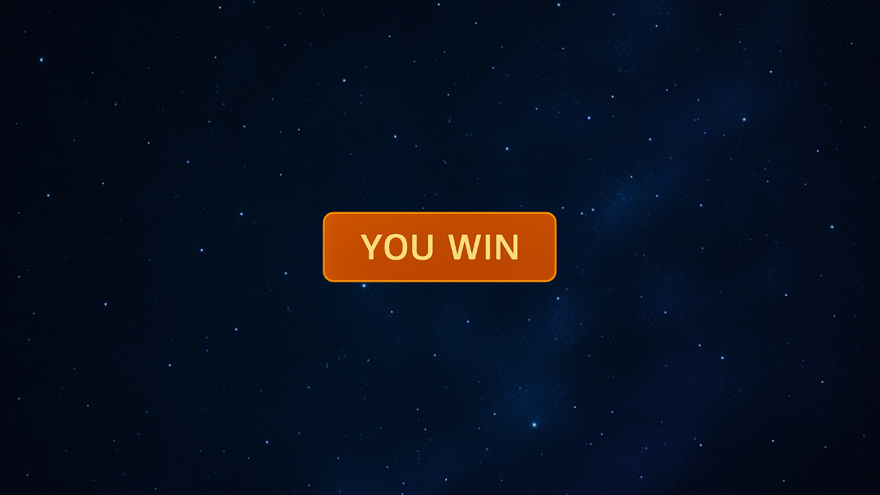

**Logo:** Font Style: Sans-serif bold (same theme)

Text Size Estimate: ~48–60pt

Text Color: RGB(255, 255, 255)

Background Color: RGB(255, 140, 0) (bright orange)

Glow: RGB(255, 165, 0)

Location: 651, 651

**Game over screen:**

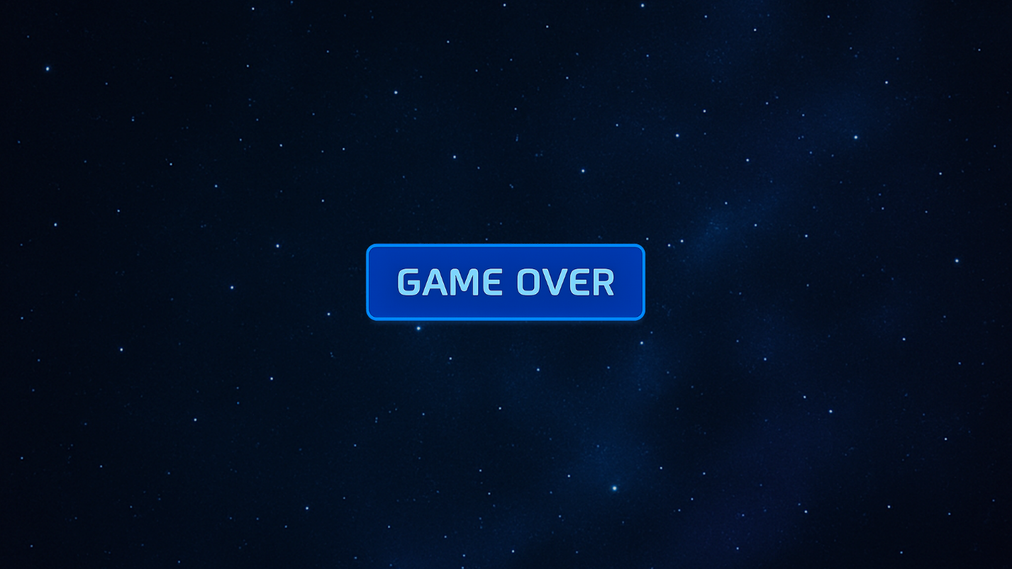

**Logo:** Font Style: Same family as START button (bold + sci-fi)

Text Size Estimate: ~48–60pt

Text Color: RGB(255, 255, 255)

Gradient Base:

RGB(30, 30, 60) to RGB(50, 50, 100)

Glow: RGB(0, 140, 255)

Location: 651, 651

**Level 1 to Level 5 logo:** 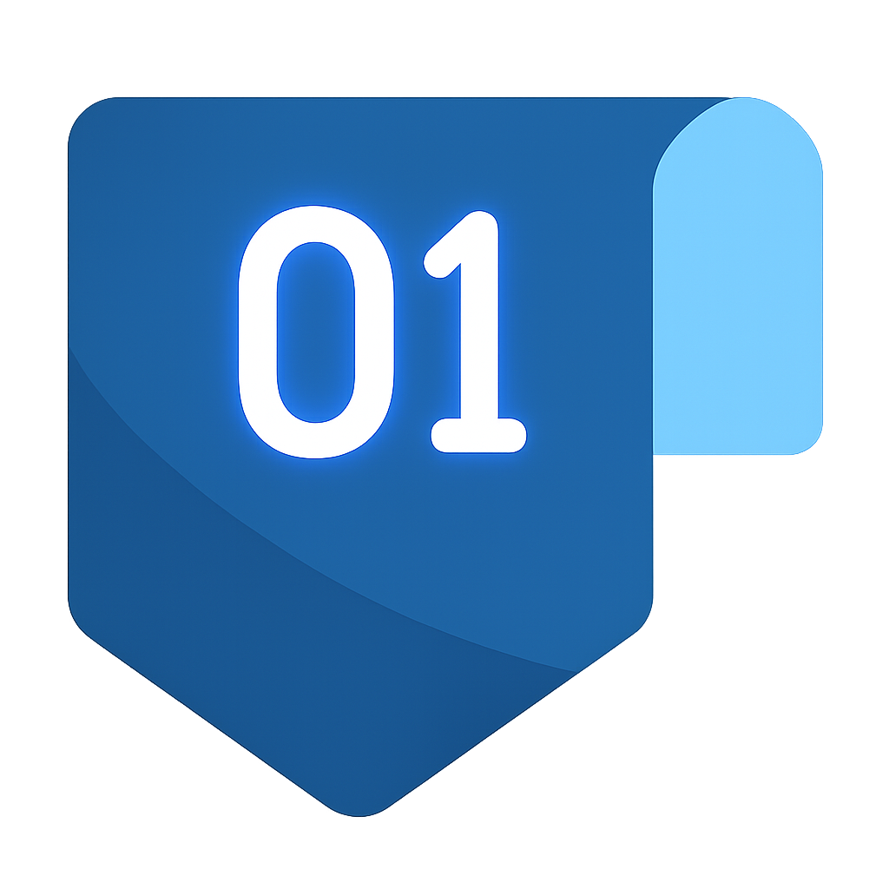

Style: Modern flat design with soft gradients and glowing effect

Shape: Rectangular badge with a pointed bottom (like a downward-facing ribbon)

Corner Detail: Folded top-right corner in a lighter blue, giving it a 3D tab look

Main Number: Large, centered, sans-serif font with glowing white/blue hue

**Main Badge Background**

* **Color**: Deep space blue
* **RGB**: rgb(27, 99, 163)
* **Hex**: #1b63a3

**2. Folded Tab (Top Right)**

* **Color**: Sky blue / cyan tint
* **RGB**: rgb(135, 206, 250)
* **Hex**: #87cefa

**3. Number Text ("01" to "05")**

* **Color**: White with slight blue glow
* **RGB (base white)**: rgb(255, 255, 255)
* **Glow tint**: Slight neon blue glow effect
* **Approximate RGB of glow**: rgb(0, 191, 255)
* **Hex**: #00bfff

**4. Gradient/Shadow Effect**

* There is a subtle curved gradient on the badge, adding depth:
  + **Bottom left shading**: darker tone – approximately rgb(19, 80, 134)
  + **Top section**: slightly lighter – approximately rgb(36, 118, 185)

**Font**

* **Type**: Rounded sans-serif (similar to *Roboto*, *Poppins*, or *Montserrat*)
* **Weight**: Medium to bold
* **Style**: Regular (no italics or serif)

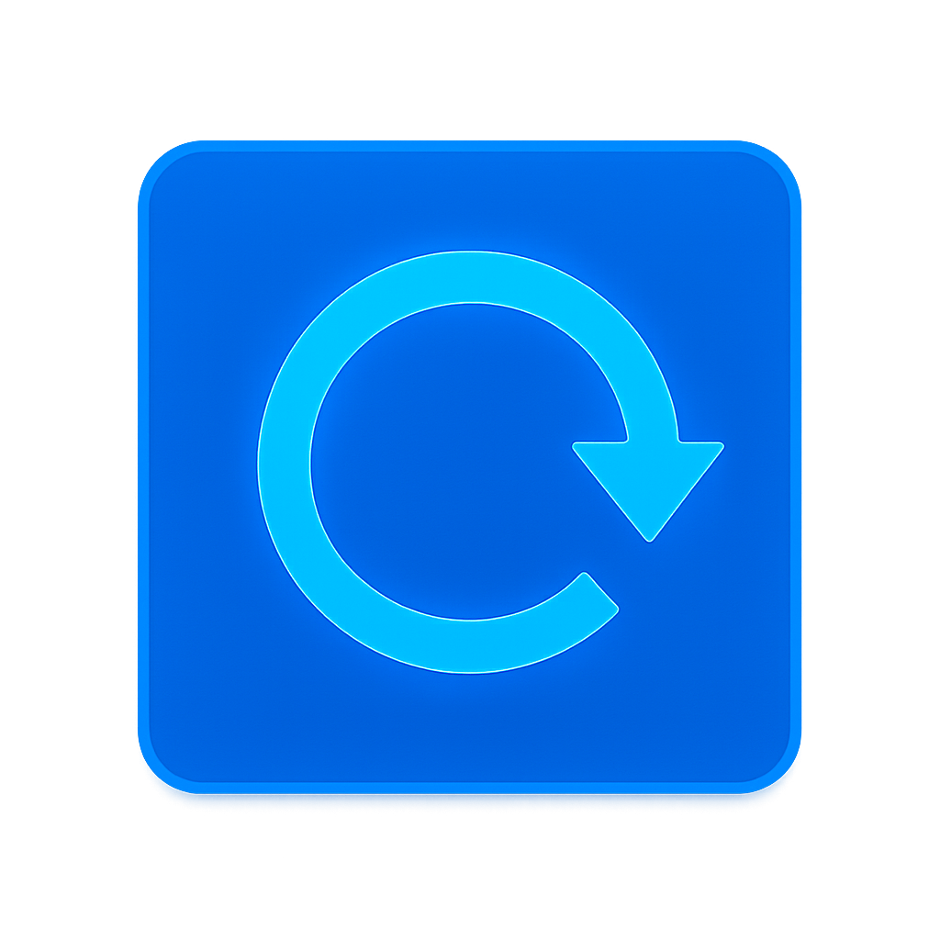

**Reset and Play button:**

**Background Square (both buttons)**

* **RGB: 0, 119, 255**
* **HEX: #0077ff**

**Icon (Play triangle / Reset arrow)**

* **RGB: 0, 191, 255**
* **HEX: #00bfff**

**Outer Glow / Border Highlight**

* **RGB: 0, 153, 255**
* **HEX: #0099ff**

